MAHARAJA SURAJMAL INSTITUTE OF TECHNOLOGY


DATA COMMUNICATION NETWORK

ASSIGNMENTS

Submitted to:

Ms. Ashish Kumari
(Associate Professor)

(Department of Applied Sciences, MSIT)

Submitted by:

Ritika
IT-2 (20)

20115003118

Assignment-1

Ques1

a) explain congestion and different types of congestion?

Ans: A state occurring in network layer when the message traffic is so heavy

that it slows down network response time.

Effects of Congestion

- As delay increases, performance decreases.

- If delay increases, retransmission occurs, making situation worse.

Types of congestion:
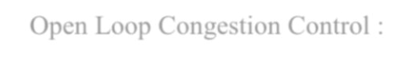

- Open Loop Congestion Control :

Open loop congestion control policies are applied to prevent congestion before it

happens. The congestion control is handled either by the source or the destination.

Policies adopted by open loop congestion control –

    - Retransmission policy

    - Window policy

    - Discarding policy

    - Acknowledgement policy

    - Admission policy

- Closed Loop congestion Control:

Closed loop congestion control technique is used to treat or alleviate congestion after it happens. Several techniques are used by different protocols; some of them are:

  - Backpressure

  - Choke packet technique
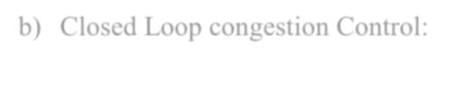

b) List advantage and disadvantage of fixed routing.

Ans: Fixed Routing –

- A route is selected for each source and destination pair of node in the network.

- The route is fixed ; changes only if the topology of the network changes.
Advantages –

- Simple

- Works well in reliable network with stable load in reliable network

- Same for virtual circuit and datagram

Disadvantages –

- Lack of flexibility

- Doesn’t react to failure or network congestion

Ques 2 : Explain IPV4 in detail.

Ans: IP stands for Internet Protocol and v4 stands for Version Four (IPv4). IPv4 was the primary

version brought into action for production within the ARPANET in 1983.

IP version four addresses are 32-bit integers which will be expressed in hexadecimal notation.

Example- 192.0.2.126 could be an IPv4 address.

Parts of IPv4

- Network part : The network part indicates the distinctive variety that’s appointed to the network. The network part conjointly identifies the category of the network that’s assigned.

- Host part : The host part uniquely identifies the machine on your network. This part of the IPv4 address is assigned to every host.

For each host on the network, the network part is the same, however, the host half must vary.

- Subnet Number : This is the nonobligatory part of IPv4. Local networks that have massive numbers of hosts are divided into subnets and subnet numbers are appointed to that.

Characteristics of IPv4

- IPv4 could be a 32-Bit IP Address.

- IPv4 could be a numeric address, and its bits are separated by a dot.

- The number of header fields is twelve and the length of the header field is twenty.

- It has Unicast, broadcast, and multicast style of addresses.

- IPv4 supports VLSM (Virtual Length Subnet Mask).

- IPv4 uses the Post Address Resolution Protocol to map to the MAC address.

- RIP may be a routing protocol supported by the routed daemon.

- Networks ought to be designed either manually or with DHCP.

- Packet fragmentation permits from routers and causing host.
Advantages of IPv4

- IPv4 security permits encryption to keep up privacy and security.

- IPV4 network allocation is significant and presently has quite 85000 practical routers.

- It becomes easy to attach multiple devices across an outsized network while not NAT.

- This is a model of communication so provides quality service also as economical knowledge transfer.

- IPV4 addresses are redefined and permit flawless encoding.

Ques 3 : Difference between SMTP and FTP.

Ans:

Feature | FTP |  | SMTP
TCP port
number | 20 and 21 | 25
RFC reference
documents | RFC959 |  | RFC821, RFC822 and RFC974
 | Used to transfer files from |  | Used to e-mail send messages between
Protocol | remote computer after |  | computers. This is done either using
function | connection is established |  | SMTP server or using mail function.

Assignment-2

Ques 1 : What is switching? Explain difference between circuit and packet switching.

Ans: Switching: Switching is process to forward packets coming in from one port to a port leading towards the destination. When data comes on a port it is called ingress, and when data leaves a port or goes out it is called egress. A communication system may include number of switches and nodes. At broad level, switching can be divided into two major categories:

- Connectionless: The data is forwarded on behalf of forwarding tables. No previous handshaking is required and acknowledgements are optional.

- Connection Oriented: Before switching data to be forwarded to destination, there is a need to pre-establish circuit along the path between both endpoints. Data is then forwarded on that circuit. After the transfer is completed, circuits can be kept for future use or can be turned down immediately.

Difference:

Circuit Switching | Packet Switching
A circuit needs to be established to make | Each packet containing the information that
A circuit needs to be established to make | needs to be processed goes through the
sure that data transmission takes place. | needs to be processed goes through the
sure that data transmission takes place. | dynamic route.
A uniform path is followed throughout the | There is no uniform path that is followed
session. | end to end through the session.
It is most ideal for voice communication, | It is used mainly for data transmission as the
while also keeping the delay uniform. | delay is not uniform.
Without a connection, it cannot exist, as the | A connection is not necessary, as it can exist
connection needs to be present on a physical | without one too. It needs to be present on a
layer. | network layer.
Data to be transmitted is processed at the | Data is processed and transmitted at the
source itself. | source as well as at each switching station.

Ques 2 : Explain Sliding window protocol.

Ans: The sliding window is a technique for sending multiple frames at a time. It controls the data packets between the two devices where reliable and gradual delivery of data frames is needed. It is also used in TCP (Transmission Control Protocol).

In this technique, each frame has sent from the sequence number. The sequence numbers are used to find the missing data in the receiver end. The purpose of the sliding window technique is to avoid duplicate data, so it uses the sequence number.

Types of Sliding Window Protocol

Sliding window protocol has two types:

- Go – Back – N ARQ

Go – Back – N ARQ provides for sending multiple frames before receiving the acknowledgment for the first frame. It uses the concept of sliding window, and so is also called sliding window protocol. The frames are sequentially numbered and a finite number of frames are sent. If the acknowledgment of a frame is not received within the time period, all frames starting from that frame are retransmitted.

- Selective Repeat ARQ

This protocol also provides for sending multiple frames before receiving the acknowledgment for the first frame. However, here only the erroneous or lost frames are retransmitted, while the good frames are received and buffered.

Ques 3 : Describe token ring and token bus in detail.

Ans: Token Ring

Token ring (IEEE 802.5) is a communication protocol in a local area network (LAN) where all stations are connected in a ring topology and pass one or more tokens for channel acquisition. A token is a special frame of 3 bytes that circulates along the ring of stations. A station can send data frames only if it holds a token. The tokens are released on successful receipt of the data frame.

Token Passing Mechanism in Token Ring

If a station has a frame to transmit when it receives a token, it sends the frame and then passes the token to the next station; otherwise it simply passes the token to the next station. Passing the token means receiving the token from the preceding station and transmitting to the successor station. The data flow is unidirectional in the direction of the token passing. In order that tokens are not

circulated infinitely, they are removed from the network once their purpose is completed. This is shown in the following diagram −
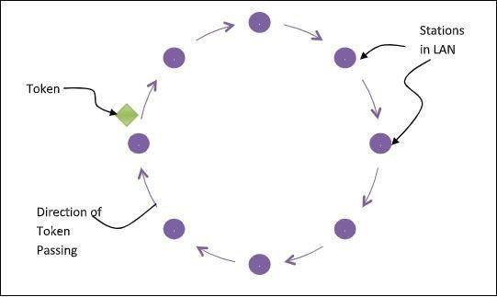

Token Bus

Token Bus (IEEE 802.4) is a standard for implementing token ring over virtual ring in LANs. The physical media has a bus or a tree topology and uses coaxial cables. A virtual ring is created with the nodes/stations and the token is passed from one node to the next in a sequence along this virtual ring. Each node knows the address of its preceding station and its succeeding station. A station can only transmit data when it has the token. The working principle of token bus is similar to Token Ring.

Token Passing Mechanism in Token Bus

A token is a small message that circulates among the stations of a computer network providing permission to the stations for transmission. If a station has data to transmit when it receives a token, it sends the data and then passes the token to the next station; otherwise, it simply passes the token to the next station. This is depicted in the following diagram −
